# Technology

1. Spring boot
2. Angular 7
3. MySQL 8

# Database setup

1. Create db name with “mortgage_loan”.
2. Import mortgage_loan.sql file.
3. I have already inserted some test data.

# Environment Variable

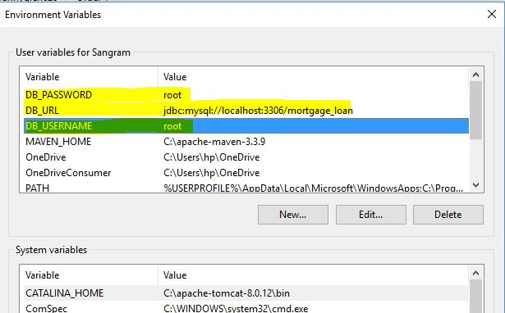

# Java Project

1. Extract MortgageLoan-API.zip file.
2. Import to eclipse as existing maven project.
3. Change email and password from com.Mortgage.MortgageLoanAPI.utils. Constants file
4. Run the project.
5. Base url : <http://localhost:8080/>

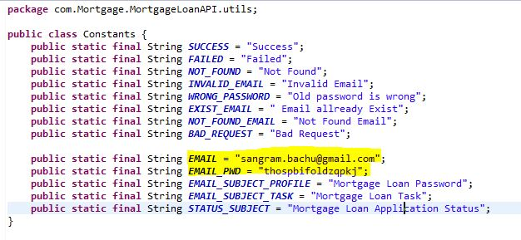

# UI Setup

1. Install nodejs
2. Install angular cli
3. Extract mortgage-ui.zip file.
4. Change base url accordingly in mortgage-ui\src\app\baseUrl.ts file

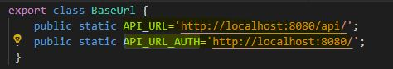

1. Go to the project folder and run below command.
   1. Npm install
   2. Ng serve

Then go to below urls

1. USER Login : http://localhost:4200/login
2. Admin and Employee Login : http://localhost:4200/emp-login